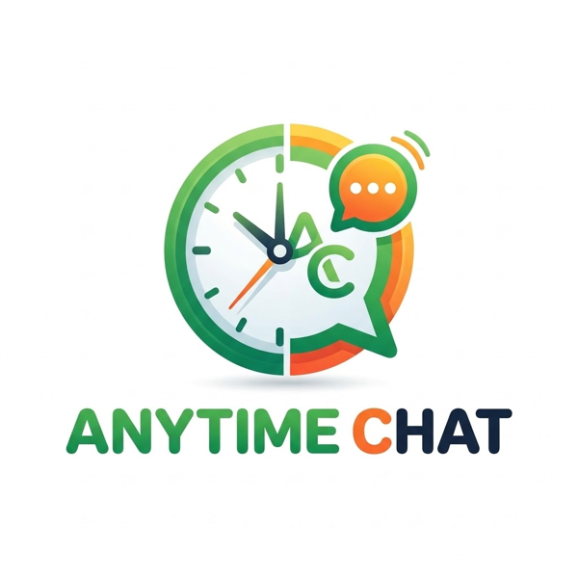
Wati Setup Manual
A plain-language guide to signing up for Wati and connecting your WhatsApp number
Affiliate disclosure: Anytime Chat is a Wati affiliate. If you subscribe to Wati through our links we may earn a commission, at no extra cost to you. We are an independent guide, not Wati. Your agreement for the Wati service is directly with Wati.

Version: 5 October 2026. Wati and Meta change their screens, prices and rules often. If something here no longer matches what you see, trust Wati and Meta, and tell us so we can update this guide.

1. What this manual is for
Wati is a platform that lets a business use the official WhatsApp Business API with a shared team inbox, broadcast messages, templates and chatbots. This manual walks you through signing up for Wati and connecting your WhatsApp number, so you can do it yourself. If you would rather be guided, see section 10.

2. What Wati provides
- Official WhatsApp Business API access (Meta-approved).
- A shared team inbox, so several people can answer from one number.
- Broadcast messages to opted-in contacts, using Meta-approved templates.
- Chatbots and automation: auto-replies, menus and simple flows.
- Integrations (for example Shopify) and an API on higher plans.
Which features you get depends on your plan. Always check the current list on wati.io.

3. What Wati costs
The prices below are indicative, in US dollars per month, and depend on whether you pay monthly or annually (annual is cheaper). Prices change, so confirm at wati.io/pricing before you buy.
Plan | Indicative price | Good for
Growth | About US$25 to $49 per month | Small teams starting out: shared inbox, broadcasts, basic automation, 3 users
Pro | About US$49 to $99 per month | Growing teams: advanced chatbots, more automation, 5 users, longer support hours
Business | About US$99 to $299 per month | High volume: more integrations, multiple numbers, dedicated support

Also expect:
- A 7-day free trial. There is no permanent free plan.
- Meta message fees. Meta charges per message (marketing, utility, authentication), and the amount depends on the country. Wati passes these on, sometimes with a small markup.
- Extra users and some add-ons cost extra.
- Wati's terms state that paid subscriptions are non-cancellable and non-refundable. Use the free trial first.

4. Before you start: your checklist
- A business email address you can access.
- A Meta (Facebook) Business Portfolio where you are the admin. If you do not have one, create it at business.facebook.com first.
- A phone number for WhatsApp. It must NOT already be registered on WhatsApp, and it must be able to receive an SMS or phone call for the verification code.
- Your business details: legal or trading name, country, time zone, business category, and a website if you have one.
- A display name that follows Meta's naming rules (it should match your business and not be generic).
- A payment method for Wati's subscription.

Important: use a dedicated number, not your everyday WhatsApp. If the number is already on WhatsApp or WhatsApp Business, you will usually have to delete that account first, and you will lose its chats unless you back them up. Wati also supports a "coexistence" option on some numbers that lets the number work in both places. Ask Wati whether your number qualifies before you start.

5. Step-by-step: sign up and connect your number
These steps follow Wati's own Embedded Signup process at the time of writing. Screens may look slightly different.
- Start your free trial. Use the Wati link on our Wati page (anytime-chat.co.za/wati) and create your Wati account with your business email.
- Choose a plan when your trial is ready to upgrade. Check the price and billing period before you confirm.
- Open the connection option. In Wati, choose to connect a number using Embedded Signup (Cloud API).
- Enter your number and details. Type your WhatsApp number, choose your display name, add your website (optional but recommended) and pick your business category.
- Continue with Facebook. Make sure you are logged into the correct Meta account and the correct Business Portfolio before you continue.
- Accept the terms. Read and accept the terms on screen.
- Fill in your business information. Business name, category, country, website and time zone.
- Create your WhatsApp Business Account (WABA). Create a new one and a business profile with your account name and display name.
- Verify your number. Meta sends a one-time code by SMS or phone call. Enter it yourself. Never send this code to anyone, including us.
- Review the permissions you are giving Wati on your Meta account, then select Finish.
- Check it worked. Back in Wati your number should show as connected. Send a test message to your own phone.

Testing with a free number. Meta can give you a free test number so you can look around. It has no verification code and cannot run campaigns or reach full sending limits. Upgrade to your real, verified number when you are ready.

6. After you connect

Message templates
Outside a 24-hour customer-initiated chat window, you can only send messages that use a template Meta has approved. Create templates in Wati, choose the right category (marketing, utility or authentication), keep the wording clear, and wait for approval.

Opt-in and opt-out
Only message people who have agreed to hear from you on WhatsApp. Keep a record of how and when they agreed. Honour opt-outs straight away. This protects your number and is required by Meta, Wati and POPIA.

Sending limits and quality
Meta limits how many new people you can message per day, based on your verification status and your number's quality rating. Unverified accounts start with a small daily limit. Send useful messages to people who want them so your quality stays high.

Business verification
Verifying your business with Meta is optional but recommended, because it raises your limits. You will need legal documents for your business and a working website. Meta decides this, and it can take days. Wati warns that leaving out a website can cause problems at verification.

7. The rules you agree to follow
When you use Wati you agree to Wati's terms, and to Meta's WhatsApp Business Terms and WhatsApp Business and Commerce Policies. In short:
- Get consent before messaging, and only upload data you are legally allowed to use.
- Do not use WhatsApp for illegal activity, false advertising, counterfeit goods, controlled substances, gambling, hate speech or other prohibited content.
- Stay within Meta's message limits and quality rules.
- Wati or Meta can restrict, suspend or ban an account or number that breaks the rules. We cannot reverse that.
These are summaries. The full, current documents on wati.io and Meta's website are what apply.

8. Troubleshooting
Problem | What to try
"Number already registered" | The number is already on WhatsApp or WhatsApp Business. Delete that account (back up chats first) or use another number. Ask Wati about coexistence.
No verification code arrives | Choose the phone-call option instead of SMS, check the number is correct and the SIM has signal, then wait a few minutes before trying again.
Cannot find or select your Business Portfolio | Make sure you are logged into the right Facebook account and that you are an admin of the portfolio.
Display name rejected | Use your real business name, avoid generic words, and keep to Meta's naming rules, then resubmit.
Template rejected | Make the wording clearer, choose the correct category, remove anything promotional from a utility template, then resubmit.
Number restricted or banned | Contact Wati support and follow Meta's appeal steps. This is decided by Wati and Meta, not by Anytime Chat.

9. Keeping yourself safe
- We will never ask for your passwords, and you enter every verification code yourself.
- We contact you only from hello@anytime-chat.co.za or WhatsApp +27 82 610 7380 (help line) or +27 83 228 2406 (sales). If anything else claims to be us, check with us first.
- Do not add your own payment method to a WhatsApp Business Account unless Wati tells you to. Wati bills its subscription directly.
- Keep your own logins private, and use two-step verification on your Meta account.

10. Want help? Guided setup
If you would rather be walked through the steps, we offer guided setup for R250 (about US$14 or £11), once-off, paid securely with Flutterwave. Fill in the short form at anytime-chat.co.za/wati/help.
- The fee covers our guidance only. Wati's subscription and Meta's message fees are paid to them.
- You stay in control of your own Wati and Meta accounts.
- We cannot promise a particular outcome, approval or timeline, because they depend on Wati, Meta and your documents.

11. Terms in brief
- We are a window to Wati. We are not Wati and cannot change your Wati account, billing or support tickets.
- We are not responsible for bad behaviour by third parties or anything that goes wrong during setup, including a rejected, restricted or banned number, failed verification, lost chats, or changes to Wati's or Meta's products, prices or rules.
- Our liability for guided setup is limited to the fee you paid us for it, to the extent the law allows.
- Full terms: anytime-chat.co.za/wati/terms

12. Contact us
WhatsApp help line (support) | +27 82 610 7380
WhatsApp sales | +27 83 228 2406
Email | hello@anytime-chat.co.za
Website | anytime-chat.co.za/wati

Anytime Chat is operated by Xactavent (Pty) Ltd. Wati is a trademark of its owner and is not affiliated with us other than through its affiliate programme.

